- Third graders will never have more than 30 minutes of homework in one day.
- One subject should not be more than 10 minutes of work.
- Homework will always be a topic covered in class that needs extra practice for mastery and never a new topic.
- Third graders should be able to do homework independently with hints from an adult if necessary.
- If any problems are too difficult to complete, please circle the problem and bring the work back to school. This will allow me to re-teach the unknown work!
- Students typically finish their work in class but any unfinished assignments for the day will be homework.
- The students homework folder has a “to do” side that will have work that needs to be completed or forms to be signed.
- The folder also has a “stay home” side with information for parents and graded work.
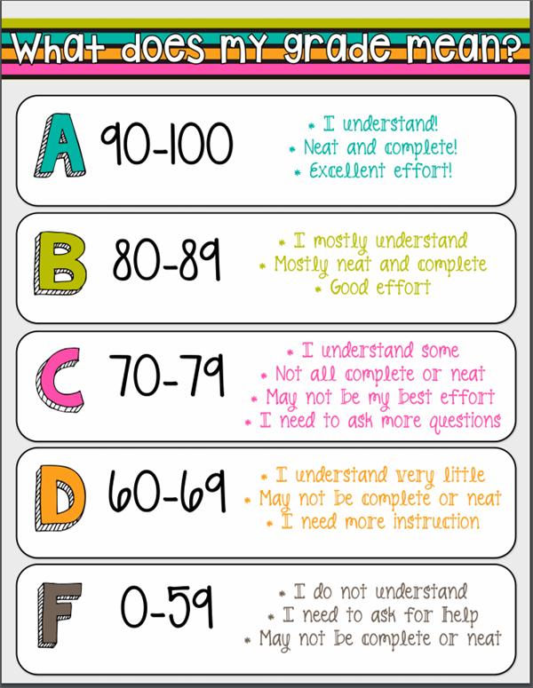
GRADED ASSIGNMENTS
- All graded classroom assignments may be corrected/changed to show understanding.
- Grades will be altered to show the improved understanding.
- All test grades are final, but extra practice can be applied to the grade.

